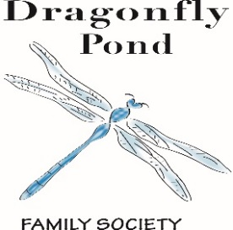
The Pond on

October 2018

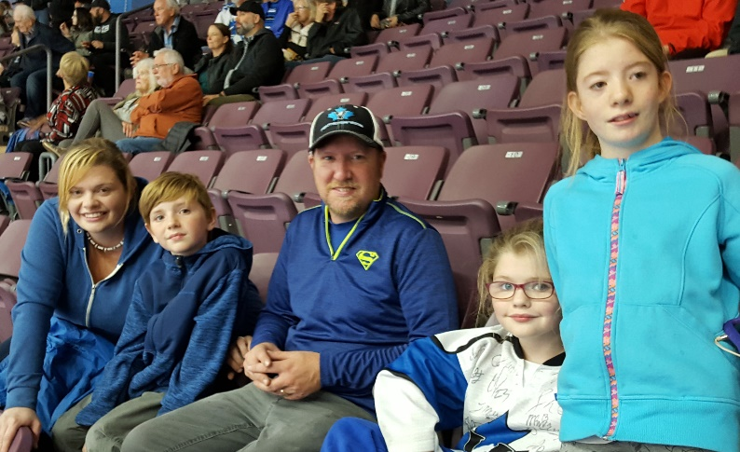

Board of Directors
Michelle Allin
Stacy Amy
Tracy Westmoreland
Nicole Baker
Victoria Umunna

Together We Will Fly….

Our programs are made possible by the generous support of our Community Sponsors:
United Way, Community Foundation South Okanagan Similkameen,
Hudson’s Bay, The Pasta Factory, Sandman Hotel Penticton, Penticton Lakeside Resort, Ramada Penticton Hotel & Suites

Dragonfly Pond Family Society
250-490-3305
dragonfly@vip.net
www.dragonflypondsociety.com
PO Box 24077, Penticton B.C. V2A 8L9

Family Stories

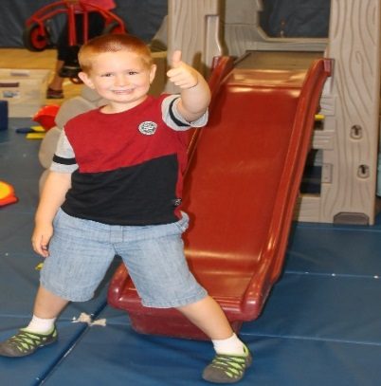

Joining Dragonfly Pond Society has been such a rewarding experience for my son and me. I am a single mother raising a son with Autism. This group has provided us with wonderful opportunities to meet and connect with other families in an environment that is welcoming and inclusive. My son has formed wonderful new friendships, and I have the chance to talk with other parents of children with special needs who truly understand my situation.
Their summer programming provided my son with numerous fun activities such as art classes, indoor rock climbing and gym time all in a group where he felt safe, included, and comfortable to try new activities. As a single parent on a limited income it's truly a blessing to be a part of a group like DFP as it provides my son with fun activities that otherwise I may not be able to afford.
Joining DFP has truly made us feel like we have a sense of belonging, and a much-needed support network. We look forward to the many fun activities they plan throughout the year! I would strongly recommend any family who has children with special needs join DFP. It's truly made a wonderful impact on our lives.

Donor Spotlight
Dragonfly Pond would like to thank The Fest of Ale for the grant that we received! To date nearly $700.000.00 of proceeds has been gifted back to the community because of the Okanagan Fest of Ale. Thank you, Okanagan Fest of Ale, for supporting your community and making us a part of your generosity!
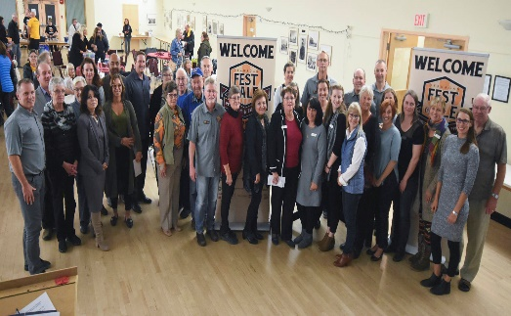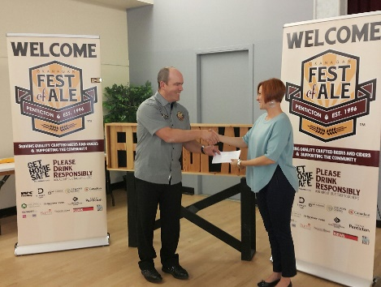

Dragonfly Pond was chosen as a Vees Community Hero at their home game on October 24th. The Penticton Vees are giving $1000.00 at 28 home games this season to a Community Hero. Thank you, Penticton Vees, for thinking of your community and including Dragonfly Pond in your success.
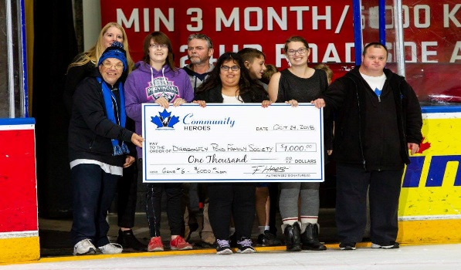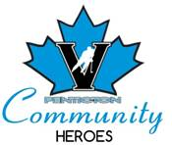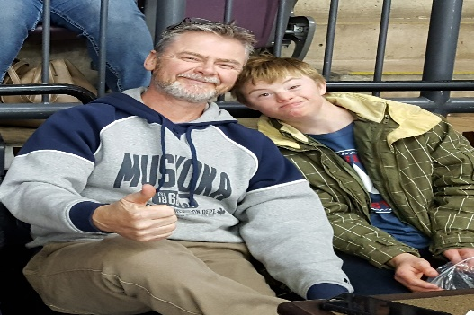

What’s New…
Web Site! Word Press South Okanagan has donated their time to help Dragonfly Pond put together a new website. Thank you, WordPress South Okanagan. Our new website will be coming soon!
Family Get Together: The Family Get Together is held once a month at various locations in the community. The next Family Get Together is being held on November 3rd from 12:45-1:45 at McLaren Arena. All skaters, including parents, will require a CSA approved hockey helmet to go on the ice. McLaren arena will provide the skates and Glengarry Skaters will be volunteering their time to help on the ice. Please email dragonfly@vip.net or phone 250-490-3305 if you would like to attend. More information to come over email.
Family Stories: If you have a story that you would like to share in the newsletter on how Dragonfly Pond has made a difference in your family, please email Debbie at dragonfly@vip.net.
The Family Christmas Party: The Christmas Party is just around the corner! Please fill out the registration for child to attend and receive a toy from Santa. Call Debbie @ 250-490-3305 or email dragonfly@vip.net
Respitality South Okanagan. Respitality SOS has begun. Parents and Caregivers are enjoying their dates nights and anticipating hotel stays. Thank you to the Community Foundations SOS, Penticton Lakeside Resort, The Sandman Penticton, The Ramada Inn and Suites, Barefoot Beach Resort, The Coast Hotel, The Pasta Factory, Pappa’s Firehall Bistro, Landmark Cinema 7 , The Oliver Theater, Roll n Stones Fun Centre, The South Okanagan Events Center, The Penticton Speedway, The Dream Café, Many Hats Theater and Elephant Island Winery.

DRAGONFLY POND FAMILY SOCIETY PROGRAMS ARE ALSO SUPPORTED BY…
United Way of the South Okanagan, Community Foundation South Okanagan Similkameen, Ministry of Child and Family Development, Lakeside Resort, Ramada Penticton Hotel & Suites, Sandman Hotel, The Pasta Factory, Safeway, Walmart, Rexall, Community Centre & Pool Staff, Okanagan Fest of Ale Society, Global Spectrum and the South Okanagan Events Centre, Sherwood Trophies, The Bay, The Nest and Nectar, Peach City Cruise, The Barley Mill Brew Pub and Sports Bistro, Penticton Herald, The Boys and Girls club, OSNS, BCSPCA, The Shatford Centre, Penticton Western, Elephant Island Winery, Steff Perry from Gardenpetal face art, Tim Horton’s, Sun-Rype, private consultants, community members, family members, foundations, community agencies & service providers

Volunteer Opportunities & Events

Paint Night Fund Raiser
We are holding a Paint Night Fundraiser on November 18th at 7pm at the Barley Mill Brew Pub. Tickets can be purchased through this link: https://www.paintnite.com/events/chalkboard-holiday-at-barley-mill-brew-pub-10104975
The Family Get Together
Held on the first Sunday of every month from 1-3pm with a few exceptions. Volunteers would assist parents with their children during the event. Email Debbie for the next Family Get Together at dragonfly@vip.net or call 250-490-3305.
Family Christmas Party
The Family Christmas party will take place at The Shatford Centre on SUNDAY December 16, 2018, from 1-3 pm. Volunteers are needed to help with the craft tables (instruction & support with simple crafts) as well as picking up gifts for the children from Toys for Tots and Teens. Refreshments and snacks included.
Spring Program 2019
Volunteer duties include assisting the children during various activities at the community center, set up and tear down of equipment, chairs and tables. Art in the Park volunteers needed to assist with all crafts. Please contact Debbie for details.

If you would like to volunteer with a program or fundraiser, please contact program coordinator Debbie for more details @ 250-490-3305 or by emailing dragonfly@vip.net

Dragonfly Pond Family Society
250-490-3305
dragonfly@vip.net
www.dragonflypondsociety.com
PO Box 24077, Penticton B.C. V2A 8L9

