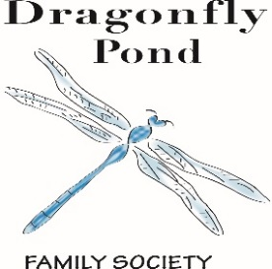
The Pond on

July 2018

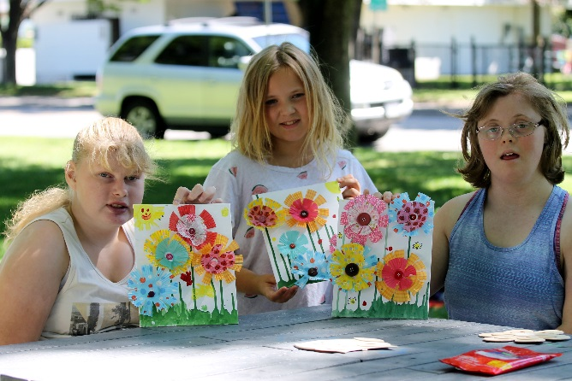

Board of Directors
Michelle Allin
Stacy Amy
Tracy Westmoreland
Nicole Baker
Victoria Umunna

Together We Will Fly….

Our programs are made possible by the generous support of our Community Sponsors:
United Way, Community Foundation South Okanagan Similkameen,
Hudson’s Bay, The Pasta Factory, Sandman Hotel Penticton, Penticton Lakeside Resort, Ramada Penticton Hotel & Suites

Dragonfly Pond Family Society
250-490-3305
dragonfly@vip.net
www.dragonflypondsociety.com
PO Box 24077, Penticton B.C. V2A 8L9

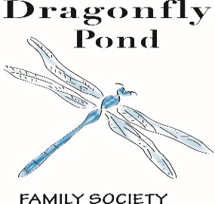
Dragonflies and Minnows Summer Programing is in full swing! It is not to late to register for the remainder of July! Please call 250-490-3305, email dragonfly@vip.net, to register. Thank you, United Way and Rexall for supporting our spring and summer programs! We have also been enjoying a daily snack at our summer programs that were generously donated by Safeway Penticton.
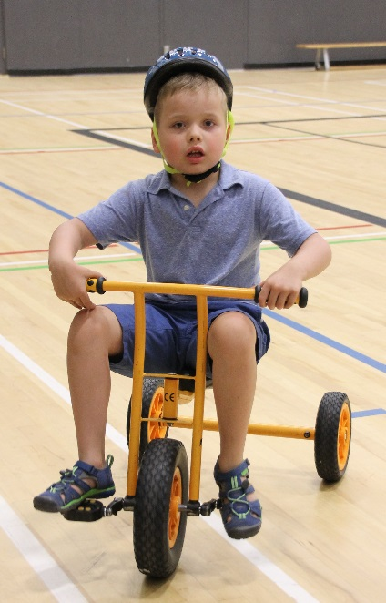
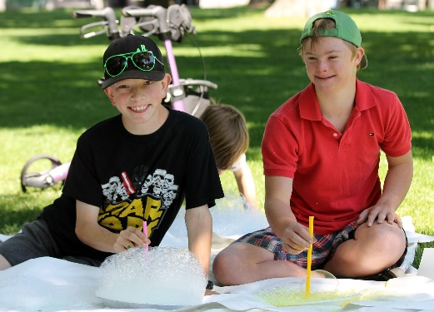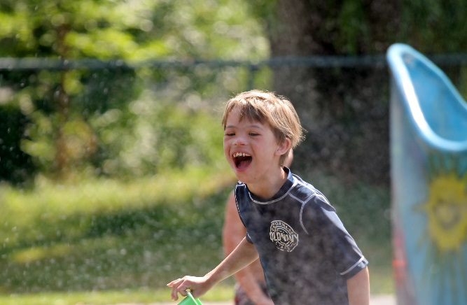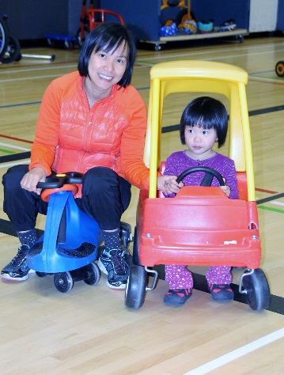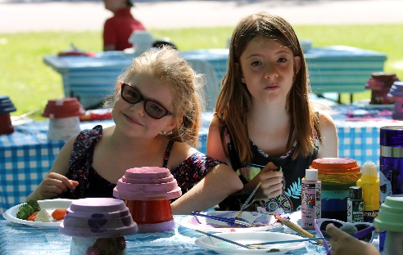

Family Stories – The Waid’s
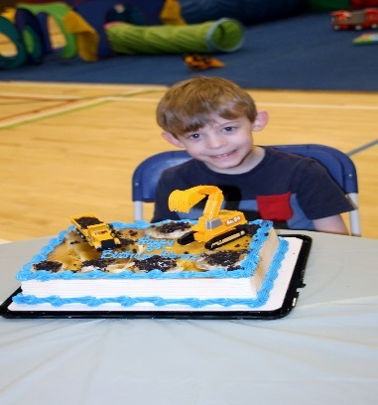
Dragonfly Pond activities allow Kieran to interact and socialize with other children in a safe and understanding environment. At Dragonfly Pond, Kieran doesn’t feel like an outcast. This year his birthday, which occurs during spring break, is being celebrated at the camp with a cake. It will be the very first birthday he can celebrate with friends, which is a very special and wonderful chance to have.

The Family Get Together: The Family Get Together is gaining interest every month with 9 families joining us at our last get together. We have done a few different activities together but the most important thing we do is connect with each other while the kids play with their friends! Join us in August at Loco Landing! Thank you to the Community Foundation SOS and Tim Hortons for supporting Dragonfly Pond Family Society Family Get Together.

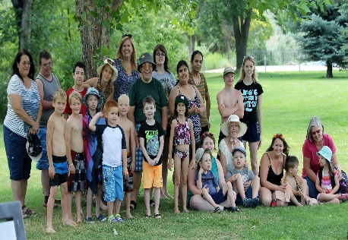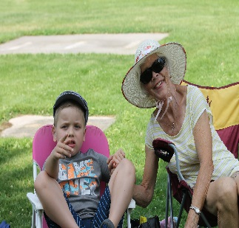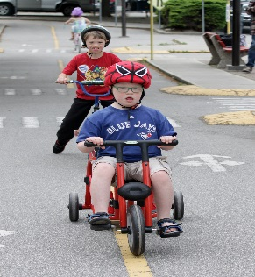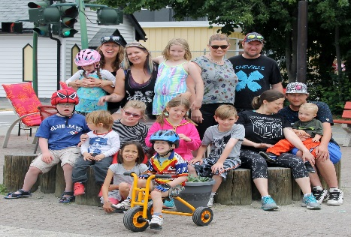

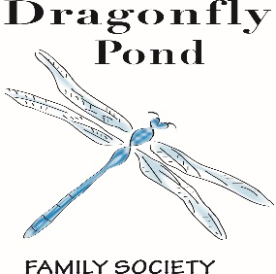
What’s New…
Family Get Together: The Family Get Together is held once a month at various locations in the community. The next Family Get Together is being held on August 30th at Loco landing at 10:00 am. The children will be receiving passes to go on 3 activities. Please email dragonfly@vip.net or phone 250-490-3305 if you would like to attend. More information to come over email.
Family Stories: If you have a story that you would like to share in the newsletter on how Dragonfly Pond has made a difference in your family, please email Debbie at dragonfly@vip.net.
2018/2019 Membership forms: The new membership forms have been emailed out. Please fill out and return a.s.a.p. as all programs require a current membership
Dragonflies and Minnows Summer Break program: The Summer program has begun, and the kids are having a blast! It is never too late to register! Call Debbie @ 250-490-3305 or email dragonfly@vip.net
Respitality South Okanagan. The sign up for the 2018/2019 Respitality season has begun. Please fill out the Respitality registration and return it asap. Thank you to the Community Foundations SOS, Penticton Lakeside Resort, The Sandman Penticton, The Ramada Inn and Suites, Barefoot Beach Resort, The Pasta Factory, Landmark Theater, The South Okanagan Events Center, The Penticton Speedway, The Dream Café, Many Hats Theater and Elephant Island Winery.

DRAGONFLY POND FAMILY SOCIETY PROGRAMS ARE ALSO SUPPORTED BY…
United Way of the South Okanagan, Community Foundation South Okanagan Similkameen, Ministry of Child and Family Development, Lakeside Resort, Ramada Penticton Hotel & Suites, Sandman Hotel, The Pasta Factory, Safeway, Walmart, Rexall, Community Centre & Pool Staff, Okanagan Fest of Ale Society, Global Spectrum and the South Okanagan Events Centre, Sherwood Trophies, The Bay, The Nest and Nectar, Peach City Cruise, The Barley Mill Brew Pub and Sports Bistro, Penticton Herald, The Boys and Girls club, OSNS, BCSPCA, The Shatford Centre, Penticton Western, Elephant Island Winery, Steff Perry from Gardenpetal face art, Tim Horton’s, Sun-Rype, private consultants, community members, family members, foundations, community agencies & service providers

Volunteer Opportunities & Events
Recycling Program:
We are looking for someone who will pick up recycling from various businesses and take to the bottle depot for return. Please contact Debbie if you can help with this program.
Summer Program 2018
Volunteer duties include assisting the children during various activities at the community center, set up and tear down of equipment, chairs and tables. Art in the Park volunteers needed to assist with all crafts. Please contact Debbie for details.
The Family Get Together:
Held on the first Sunday of every month from 1-3pm with a few exceptions. Volunteers would assist parents with their children during the event.
September Ski Swap BBQ Fundraiser, September 21st and 22nd. We are looking for volunteers to help with set up and tear down, serving customers and cooking on the BBQ. Let us know if you can help! Short shifts available! Thank you, Safeway, for sponsoring this BBQ fundraiser!
Family Christmas Party:
The Family Christmas party will take place at The Shatford Centre on SUNDAY December 16, 2018, from 1-3 pm. Volunteers are needed to help with the craft tables (instruction & support with simple crafts). Refreshments and snacks included.
If you would like to volunteer with a program or fundraiser, please contact program coordinator Debbie for more details @ 250-490-3305 or by emailing dragonfly@vip.net

