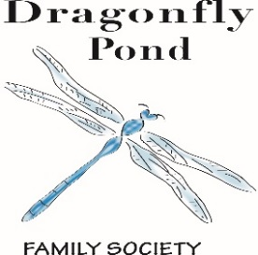
The Pond on

April 2018

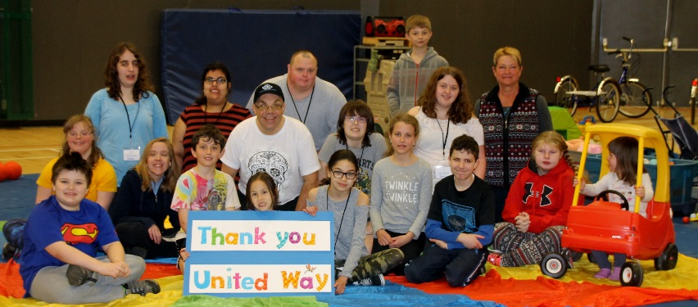

Board of Directors
Michelle Allin
Stacy Amy
Tracy Westmoreland
Nicole Baker
Victoria Umunna

Together We Will Fly….

Our programs are made possible by the generous support of our Community Sponsors:
United Way, Community Foundation South Okanagan Similkameen,
Hudson’s Bay, The Pasta Factory, Sandman Hotel Penticton, Penticton Lakeside Resort, Ramada Penticton Hotel & Suites

Dragonfly Pond Family Society
250-490-3305
dragonfly@vip.net
www.dragonflypondsociety.com
PO Box 24077, Penticton B.C. V2A 8L9

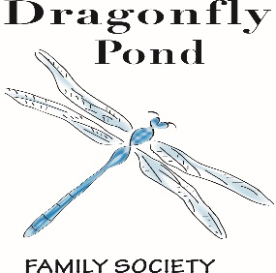

Dragonflies and Minnows Spring Programing took place at the Community Centre during the first week of spring break. Thirty-five kids attended supported by ten volunteers including our own Dragonfly Pond youth. Thank you to all our volunteers who did a fantastic job. Everyone had a wonderful time ! Stay tuned for our summer programing registration.
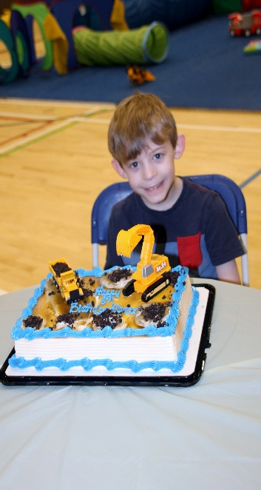
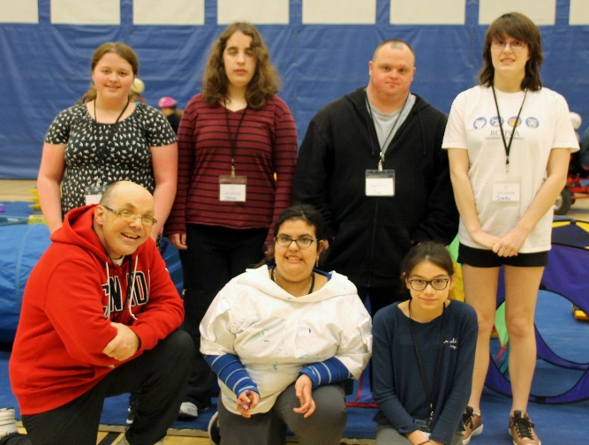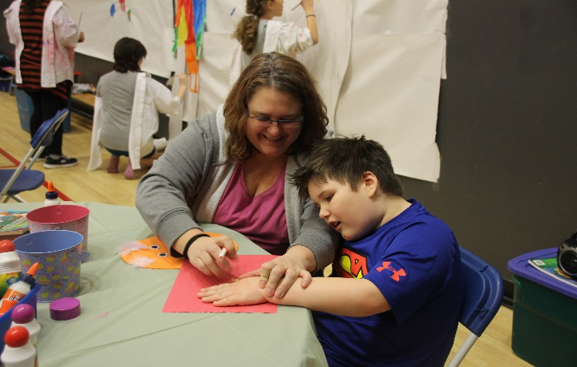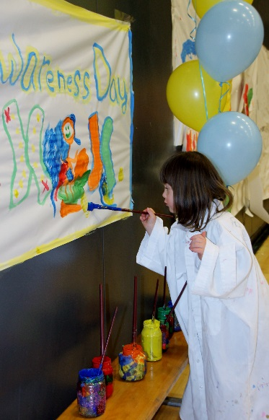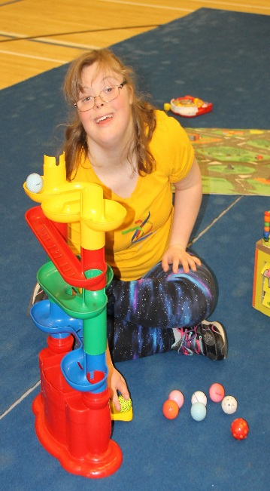

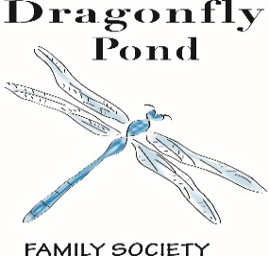
Family Stories - The Coleman’s
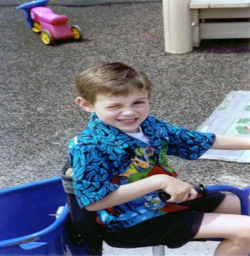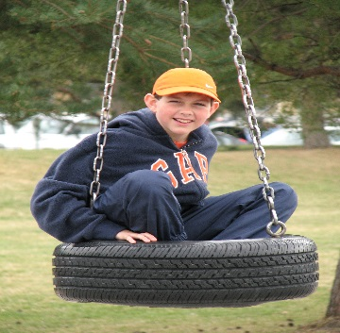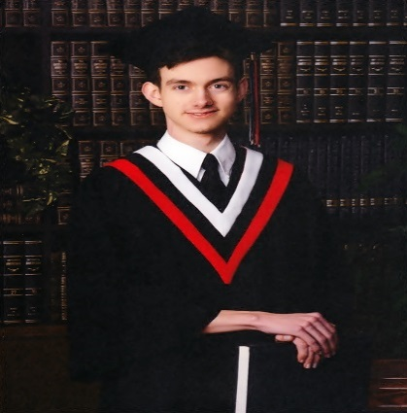
For the past 13 years Dragonfly Pond Society has been an integral part of our family and has a special place in our hearts. Our son Tristan was diagnosed with Autism in 2002 and since then our lives have been a rollercoaster ride filled with many highs and lows. From the unknown of what Autism was to the many sleepless nights wondering what this would mean for our son’s future. Through the years with Dragonfly Pond, we grew as parents and watched our son blossom into the young man he is today.
There have been many events that we have attended over the years from Spring & Summer week long programs to fundraisers and bottle drives, from swim and gym fun to Christmas parties, from cooking programs to bowling parties. Through the many events, Tristan most enjoyed the peer interaction. The many wonderful volunteers helped our son learn skills in peer interaction and communication. These skills enable our son to become less socially awkward and more confident. As the years and events went by Tristan became a bit of a leader amongst his peers and made friends some of which are still friends today.
As parents, we especially enjoyed the interaction and networking with likeminded parents whom as we found out were just as lost, confused and mentally exhausted as we were. Through the many events the parents could lean on each other, talk about each other’s experiences; almost like a parent support group. We would learn new strategies, approaches, research, treatment options and what resources were out there. The respite program was such a great support for us. The number of hotel stays, dinners out and just an evening/night out to relax was a godsend. We are so thankful for the many hours organizers and coordinators put in working with community agencies and businesses to be able to bring this kind of respite service to the many parents. Our family enjoyed all the services and programs DFP had to offer and at no cost. We participated in several fundraisers, bottle drives, volunteering all to try to give back.
Dragonfly Pond Society was an amazing resource and support for our family through several difficult years. I know in speaking with several parents that say the same thing. Tristan is now 19 and transitioning into adulthood. He is less involved with DFP but still recalls the fun times that we all had. The skills and confidence that he was able to take away from his involvement with DFP is so evident today. Thank you so much Dragonfly Pond for all that you do for not only our family but also the many others you have touched along the way

What’s New…
Roast Beef Fundraiser Dinner: The Roast Beef fundraiser is being held at the Barley Mill Brew Pub and Sports Bistro on April 29th from 5-8 p.m. There will be live music by Ken Moorman and Kyle Anderson, a 50/50 draw and silent auction. Tickets are $20.00. Please contact Debbie @ dragonfly@vip.net or 250-490-3055 if you would like to purchase a ticket. Tickets will not be sold at the door.
Family Get Together: The Family Get Together is held once a month at various locations in the community. The next Family Get Together is being held on Saturday May 5th from 1-3 p.m. at the Community Center Pool located at 325 Power Street. Please R.S.V.P. to Debbie by email dragonfly@vip.net or phone if you would like to attend.
Family Stories: If you have a story that you would like to share in the newsletter on how Dragonfly Pond has made a difference in your family , please email Debbie @ dragonfly@vip.net.
2018/2019 Membership forms: The new membership forms have been emailed out. Please fill out and return a.s.a.p. as all programs require a current membership
Dragonflies and Minnows Summer Break program: Registration information will be sent by email at the end of May or early June.
Respitality South Okanagan will continue until April 30, 2018. There will be opportunities to sign up for the 2018/2019 respitality season this July. Watch for it!

DRAGONFLY POND FAMILY SOCIETY PROGRAMS ARE ALSO SUPPORTED BY…
United Way of the South Okanagan, Community Foundation South Okanagan Similkameen, TELUS, COSTCO, Ministry of Child and Family Development, Lakeside Resort, Ramada Penticton Hotel & Suites, Sandman Hotel, Community Centre & Pool Staff, Okanagan Fest of Ale Society, Global Spectrum and the South Okanagan Events Centre, Sherwood Trophies, The Bay, The Nest and Nectar, Peach City Cruise, The Barley Mill Brew Pub and Sports Bistro, Penticton Herald, The Boys and Girls club, OSNS, BCSPCA, The Shatford Centre, Penticton Western, Elephant Island Winery, Steff Perry from Gardenpetal face art, Tim Horton’s, Sun-Rype, The Summerland Dollar Store, private consultants, community members, family members, foundations, community agencies & service providers

Volunteer Opportunities & Events
Roast Beef Dinner Fundraiser - April 29th, 2018:
The Roast Beef Dinner Fundraiser will be held at the Barley Mill Pub and Bistro. There will be live music by Kyle Anderson and Ken Moorman, a 50/50 draw and a silent auction. Tickets are $20.00. Call 250-490-3305 or email Debbie @ dragonfly@vip.net for tickets.
Recycling Program:
We are looking for someone who will pick up recycling from various businesses and take to the bottle depot for return. Please contact Debbie if you can help with this program.
Summer Program 2018 - Dates to be announced
Volunteer duties include assisting the children during various activities at the community center, set up and tear down of equipment, chairs and tables. Art in the Park volunteers needed to assist with all crafts.
The Family Get Together:
Held on the first Sunday of every month from 1-3pm with a few exceptions. Volunteers would assist parents with their children during the event.
Family Christmas Party:
The Family Christmas party will take place at The Shatford Centre on SUNDAY December 16, 2018, from 1-3 pm. Volunteers are needed to help with the craft tables (instruction & support with simple crafts). Refreshments and snacks included.
If you would like to volunteer with a program or fundraiser, please contact program coordinator Debbie for more details @ 250-490-3305 or by emailing dragonfly@vip.net

